Initiative created in 2016 by Girl Scout Troop 4778 for their Silver Award Project.  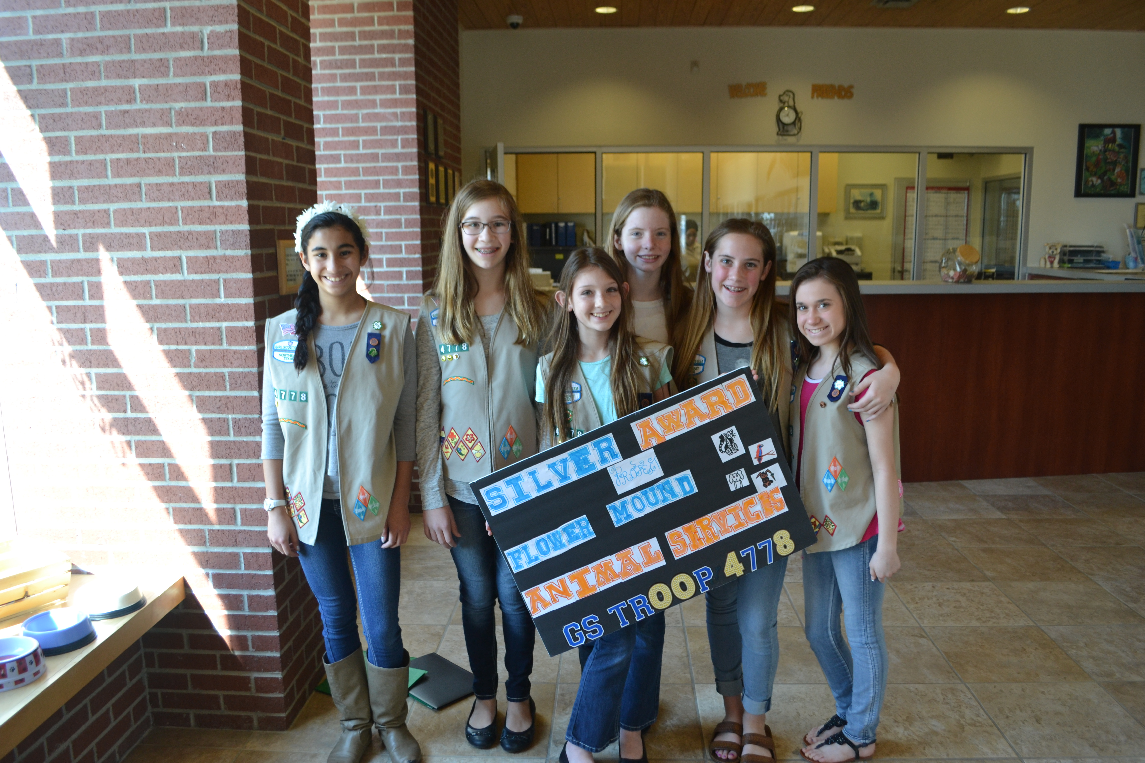Cadette Girl Scout Troop 4778 pictured from left: Maya Espinosa, Julia Vasconcellos, Lauren Peck, Caroline Oeding, Channing Mizer and Elizabeth Cohen.  The “Hand-to-Paw Month” supply drive and education campaign runs yearly from October 15th to November 15th. The Old Settlers Elementary Giving Tree Club will run the supply drive to benefit Flower Mound Animal Services and publicize its function in the community.  Locate the collection boxes at the Flower Mound Town Hall, Flower Mound Senior Center and Old Settlers Elementary School or bring your pet supplies directly to Flower Mound Animal Services and receive a custom FMAS bumper sticker.  Thank you for your support! |  |  | About Us  Flower Mound Animal Services enforces animal-related Flower Mound ordinances and works closely with local veterinarians to serve all of Flower Mound residents and pets.  Contact Flower Mound Animal Services  Phone: 972-874-6390  After Hours: 972-539-0525  Mailing Address: 2121 Cross Timbers Rd. Flower Mound, TX 75028 Physical Address: 3950 Justin Rd. Flower Mound, TX (location of the Animal Adoption Center)  Animal Adoption Center Hours of Operation Monday - Friday 9 a.m. - 5 p.m. Saturday 10 a.m. - 3 p.m. Sunday Closed Animal Services Officer On Duty Hours Monday – Friday 7 a.m. to 8 p.m. Saturday & Sunday 8 a.m. to 4 p.m.  Flower mound Animal services & Animal Adoption Center |  |  | Flower mound Animal services & Animal Adoption Center  - www.flower-mound.com select Animal Services

 | What does Flower Mound Animal Services do for the community?  Headquartered in Flower Mound’s Animal Adoption Center, the Flower Mound Animal Services division provides the following services:  - Adoption opportunities  - Pet registrations  - Educational materials  - 24-hour response to animal-related calls including dangerous or wild animal encounters, animal bites, livestock or injured animals in the roadway.  The Animal Services division also enforces animal-related Flower Mound ordinances and works closely with local veterinarians to serve all Flower Mound residents and pets.  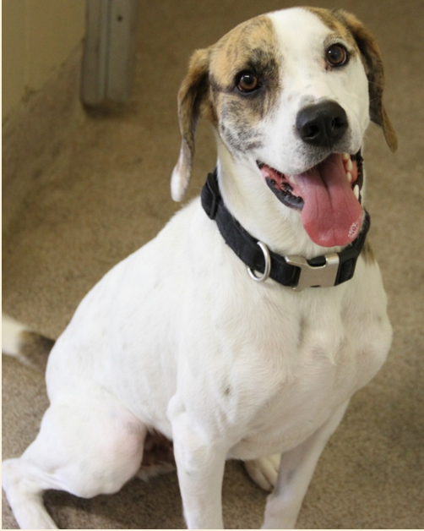 |  | Did you know… Town of Flower Mound ordinances require that all pets be registered annually?  To find this and additional important information, go to their website at:  www.flower-mound.com  select Animal Services  - Adoption information  - Animal Bite information  - Animal Impoundment  - Animal Ordinances  - Animal Registration  - Barking Dogs  - Education  - Extreme Weather Pet Info  - Free Literature Packet  - Pet Poison prevention  - Free Animal Health brochures  - Wildlife issues  - Forms  - Links to:  - TX Dept. of State Health Services  - TX Parks & Wildlife  - FEMA  - Local Wildlife Information  - Stray and lost animals  Animal Adoption:  Go online to www.flower-mound.com for a list of dogs, cats, and other pets available for adoption at:  Flower Mound Adoption Center  3950 Justin Rd.  Flower Mound, TX | How can I help?  Flower Mound Animal Services needs the following items:  - Dog food- Iams Adult and Puppy  - Cat food- Iams Adult and Kitten  - Clay non- clumping cat litter  - Gently used towels  - Kuranda dog cots/beds  - Flea and tick sprays  - Slicker brushes and nail clippers  - AA and AAA batteries  Monetary donations may be made payable to Flower Mound Animal Services and mailed to:  Flower Mound Animal Services  2121 Cross Timbers Rd.  Flower Mound, TX  75028

